Design a Parking Lot

Step 1 : Overview
We need to design a system which keeps track of vehicles that enters and exists a parking lot. It should create ticket at the entry of the vehicle, assign the appropriate parking spot, keeps and manages the state of parking spots, calculates amount and generates the bill at the exit gate when vehicle exits the parking lot. It also records the payment.

Step 2 : Requirement Gathering
- There will be a Parking Lot. The Parking Lot will have floors. Each floor will have Parking Spots.
- The Parking Lot will have multiple Entry and Exit Gates.
- At each gate, there will be an operator.
- Each Parking Spot will have supported Vehicle Types. A vehicle can only be parked on a Parking Spot, if it supports it.
- When a vehicle enters the Entry gate, a Ticket is generated for it, and a Parking Spot is assigned to it, according to a Parking Spot Strategy.
- When the vehicle exits from the exit gate, the bill is generated based on the Pricing Strategy, and the Payment is recorded.

More Polished and Structured Requirements -
- The system should support a Parking Lot containing multiple floors.
- Each floor should contain multiple parking spots.
- The parking lot should support multiple entry and exit gates.
- Each gate should be operated by an operator.
- A parking spot should support one or more vehicle types.
- A vehicle should only be parked in a compatible parking spot.
- When a vehicle enters through an entry gate, the system should generate a ticket.
- The system should assign an available compatible parking spot to the vehicle.
- The system should maintain the state of parking spots (available/occupied).
- When a vehicle exits, the system should calculate parking charges.
- The system should generate a bill.
- The system should record the payment details.

Step 3 : Identify Core Entities and Relationships

Core Entities -
- ParkingLot
- ParkingFloor
- ParkingSpot
- Gate
- Operator
- Vehicle
- Ticket
- Bill
- Payment

Enums -
- ParkingLotStatus
- ParkingFloorStatus
- ParkingSpotStatus
- GateStatus
- VehicleType
- PaymentMode
- PaymentStatus
- BillStatus

Relationships -
- ParkingLot ↔ ParkingFloor

One ParkingLot has multiple ParkingFloors and one ParkingFloor is a part of one ParkingLot. Hence the cardinality is 1 : M

- ParkingFloor ↔ ParkingSpot

One ParkingFloor has multiple ParkingSpots and one ParkingSpot is a part of one ParkingFloor. Hence the cardinality is 1 : M

- ParkingLot ↔ Gate

One ParkingLot has multiple Gates, and one Gate is a part of one ParkingLot. Hence the cardinality is 1 : M

- Gate ↔ Operator

At a time, one Gate will have one Operator and one Operator will be at one Gate. Hence the cardinality is 1 : 1

- Vehicle ↔ Ticket

One Vehicle can have multiple Tickets, and one ticket will be associated to only one Vehicle. Hence the cardinality is 1 : M.

- Ticket ↔ Bill

There will be one Bill for one ticket and one ticket for one bill. Hence the cardinality is 1 : 1.

- Bill ↔ Payment

There can be multiple payments (partial payments) for 1 bill, hence 1 bill can have multiple payments and 1 payment will be a part of only 1 bill. Hence the cardinality is 1 : M.

Step 4 : Class Diagram

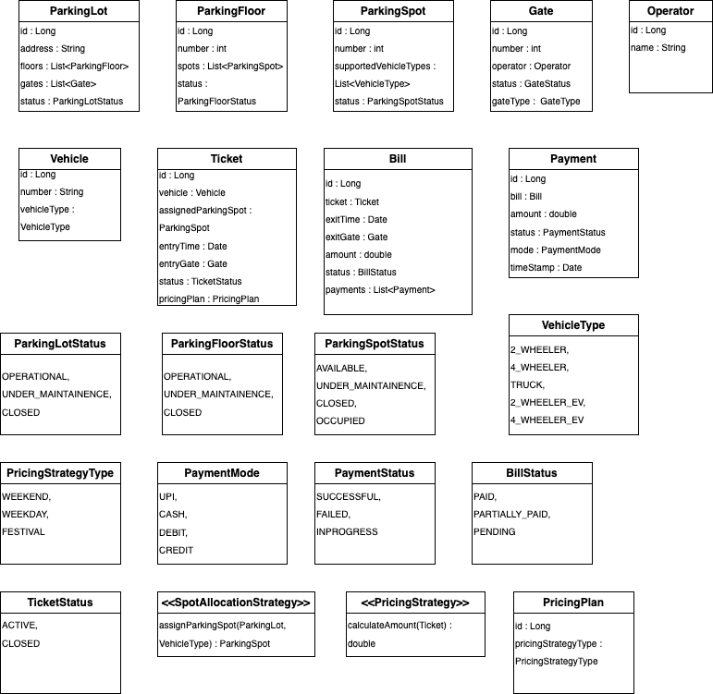

Step 5 : Schema Design

We would have the following tables ->
- ParkingLot
- ParkingFloor
- ParkingSpot
- Gate
- Operator
- Vehicle
- Ticket
- Bill
- Payment
- PricingPlan
- Gate_Operator
- ParkingSpot_VehicleType

The enums that we would store ->
- ParkingLotStatus
- ParkingFloorStatus
- ParkingSpotStatus
- VehicleType
- ParkingStrategyType
- PaymentMode
- PaymentStatus
- BillStatus
- TicketStatus
- GateType

Cardinalities ->
ParkingLot ↔ ParkingFloor = 1 : M, ParkingFloor will have Parking_lot_id
ParkingLot ↔ Gate = 1 : M, Gate will have Parking_lot_id
ParkingFloor ↔ ParkingSpot = : 1 : M, ParkingSpot will have Parking_floor_id
Ticket ↔ ParkingSpot = 1 : M. One ParkingSpot can appear in multiple Tickets over time, and one Ticket will only have one ParkingSpot. Hence Ticket will have Parking_spot_id.
Ticket ↔ Gate : 1 : M. One Gate can be a part of multiple tickets and One Ticket can have only one Gate. So Ticket will have gate_id.
Gate ↔ Operator = M : M, One gate can have many operators, and one operator can be assigned to multiple gates. So we will have a Gate_Operator mapping table which will have GateId, OperatorId, StartTime, EndTime
Ticket ↔ Vehicle = 1 : M. One Vehicle can be a part of multiple tickets, hence Ticket will have Vehicle_id
Bill ↔ Ticket = 1 : 1. One Bill will be associated with one ticket, so Bill will have Ticket_id
Bill ↔ Payment = 1 : M. One Bill can have multiple Payments (as we have partial payments allowed), hence Payment will have Bill_id.
Bill ↔ Gate. One Exit Gate will be a part of multiple Bills, and one Bill will have only one Exit gate. Hence Bill will have gate_id.
Ticket ↔ PricingPlan : 1 : M. One PricingPlan can be a part of multiple tickets, hence each ticket will have PricingPlan_id.
ParkingSpot ↔ VehicleType = M : M. One ParkingSpot can support multiple VehicleTypes, and one VehicleType can be supported by multiple Parking Spots. Hence, we will need a ParkingSpot_VehicleType mapping table which will have ParkingSpotId, VehicleTypeId.

